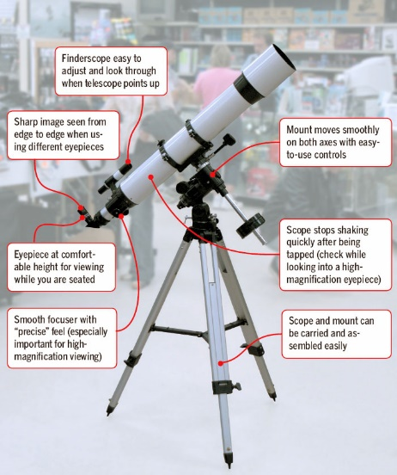**SCOPE a Picture**

**Setting** When was the picture or painting created?

What else was happening at this time?

**Caption** What does the label or title of the image say? Make some inferences.

**Objects** What do you see in the foreground of the image?

What type of people are depicted and what are they doing?

What do you see in the background of the image?

**Point of view** What do you think the creator was trying to get across in the image? Make some inferences

**Expanded meaning** What larger point or meaning can you infer or deduce from the entire composition of the image and its context?